ModelMuse with Support for PEST – Beta 6

# Summary

* The command to export the PEST control file has been renamed and the functionality is a little different.
* Prior information equations are automatically added to the PEST control file.
* The PEST Regularization mode is now supported.
* Both Singular Value Decomposition and Tikhonov regularization are supported.
* Some PEST utilities can be called from within ModelMuse.
* A regularization example is described in this document.
* The example shows how to display the model input after PEST has calibrated the model.

# Running PEST

The command for generating the PEST Control File has been renamed. It is now accessed by selecting “File|Export|PEST|Export PEST control file”. The command can also be accessed through the “down” arrow next to the “Run model” button.

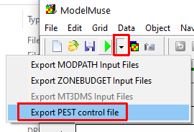

In the dialog box for running PEST, you now have a choice between not running PEST, running PESTCHEK, or running PEST. By default, it will run PESTCHEK as illustrated below.

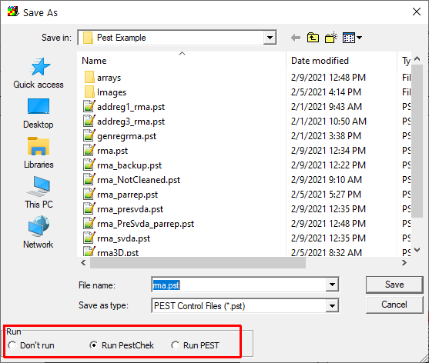

# Prior Information

There are three types of prior information that are included by default in the PEST control file: initial value prior information, within-layer continuity, and between-layer continuity. The user must also define observation groups for prior information. The prior information is defined in the “Model|PEST Properties” dialog box. The prior information equations added by ModelMuse are modeled after those that can be added using the PEST Utility program ADDREG1 and the PEST Groundwater Utility program GENREG.

## Observation Groups for Prior Information

Observation groups for prior information are defined on the “Prior Information Groups” pane. The information required for these groups is the same as for observations groups for observations.

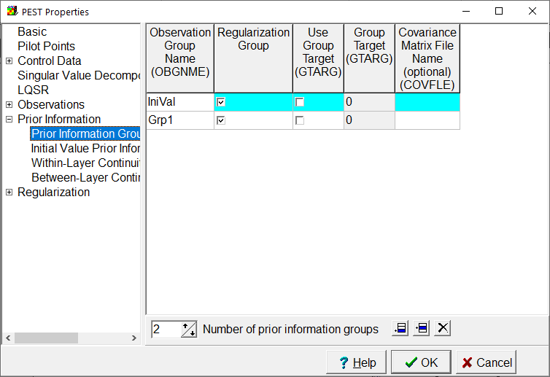

## Initial Value Prior Information

Initial value prior information is specified on the “Initial Value Prior Information” pane as illustrated below. All parameters that are not fixed or tied are listed on this pane. This type of prior information will be included if the checkbox at the top of the pane is checked. If it is checked, prior information equations will be included in the PEST control file for all the parameters in which “Define Prior Information” check box is checked. If the parameter uses pilot points, equations for the pilot points associated with the parameter will also be defined. All the prior information equations will specify that the parameter values are unchanged from their initial values. These equations are similar to the ones that would be added with the ADDREG1 PEST Utility program.

You should also select an Observation Group for each parameter for which prior information will be used. (If you don’t select one, one will be created for it when the PEST Control File is exported.)

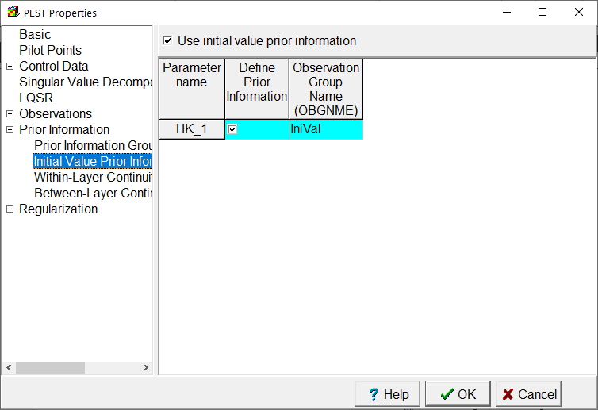

## Within-Layer Continuity Prior Information

The “Within-Layer Continuity Prior Information” is used to define prior information equations between neighboring pilot points that are all related to a single parameter of a single layer of the same data set. There is a checkbox at the top of the pane that determines whether this sort of prior information will be included in the PEST control file. The table includes parameters that are used with pilot points and are not fixed or tied. In addition, there are two additional controls: “Search Distance” and “Maximum number of pilot points”. For each related pilot point, ModelMuse will search for other pilot points that are no more than the search distance away from it. Prior information equations will be generated between the closest points within the search distance until the Maximum number of pilot points has been equaled or exceeded. The Maximum number of pilot points is not a strict limit because multiple pilot points at equal distances will all be included. For example, suppose the pilot points were arranged in a regular square grid pattern and the maximum number of pilot points was 5. For a pilot point in the center of such a grid, there would be four pilot points that were closest to it. Prior information equations would be written for all of them. Further out there would be four more pilot points that were all an equal distance from it. Rather than choosing one of these points arbitrarily, prior information equations would be written for all of them.

The equations described above would be similar to one way that the PEST groundwater utility program GENREG can create prior information equations. However, GENREG has additional options beyond what ModelMuse provides. To use those options, the user should deactivate within-layer continuity prior information for one or all of the parameters and use GENREG instead.

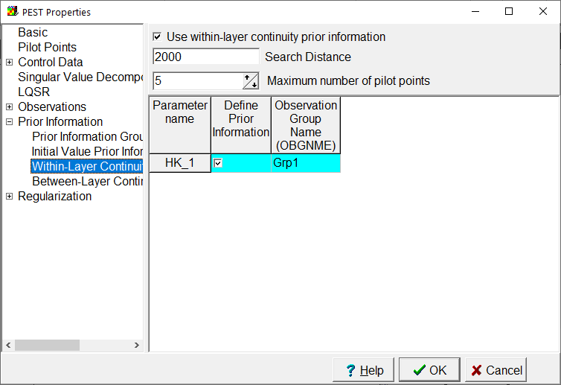

## Between-Layer Continuity Prior Information

The “Between-Layer Continuity Prior Information” is used to define prior information equations between pilot points at the same location that are all related to a single parameter in adjacent layers of the same data set. The parameters included in the table for between-layer continuity prior information are those that use pilot points.

The equations described above would be similar to one way that the PEST groundwater utility program GENREG can create prior information equations. However, GENREG has additional options beyond what ModelMuse provides. To use those options, the user should deactivate between-layer continuity prior information for one or all of the parameters and use GENREG instead.

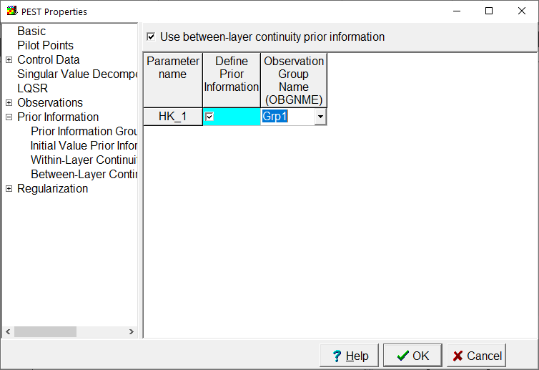

# Regularization

ModelMuse now supports using PEST in regularization mode. Values for the regularization section are specified in two panes in the “Model|Pest Properties” dialog box as illustrated below. The regularization mode is selected on the Mode pane.

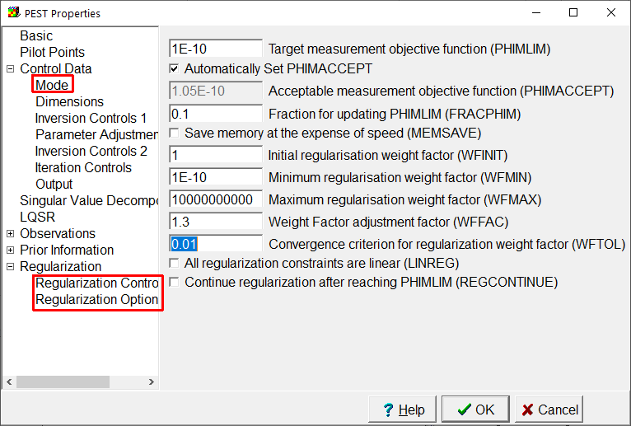

# Super Parameters

PEST allows the user to substitute “super parameters” for the user defined parameters through the use of the SVD-Assist methodology as detailed in chapter 10 of the PEST documentation. To do this, the user first must generate a .jco file that records parameter sensitivities. This is then used with the PEST utility program SUPCALC to estimate the number of super parameters that can be estimated. Next, the PEST control file is modified with the PEST utility program SVDAPREP and PEST is run with the modified PEST control file.

While these procedures can be done outside of ModelMuse, ModelMuse can help automate the process by generating the input for SUPCALC and SVDAPREP.

When the SVD-Assist methodology is used, PEST can not run the model a final time with the best parameter values. Instead, it records the best parameter values. These can be substituted into the PEST control file using the PARREP PEST Utility program. ModelMuse can run PARREP to generate a PEST control file and then run PEST with that control file.to generate the optimal model input files.

## Calculating the Number of Super Parameters

The first step in using the SVD Assist methodology is to determine the number of super parameters to use. To determine the number of super parameters, select “File|Export|PEST|Calculate Number of Super-Parameters”. The SupCalc Options dialog box will appear.

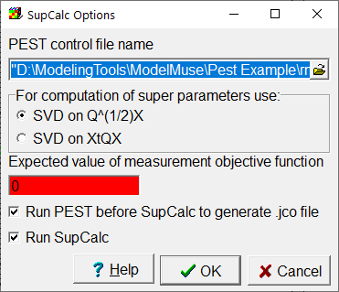

In the dialog box, the user must select an existing PEST control file to modify and specify a value greater than zero for the expected value of the measurement objective function. ModelMuse will first back up the control file you specify and export a new one in which NOPTMAX is set to -2. If the Run PEST checkbox is checked, this control file will be run by PEST to create the .jco file required by SUPCALC. After PEST has been run the backed up PEST control file will be restored. The other options in the SupCalc Options dialog box are the ones the user is most likely to wish to specify. For the remaining SUPCALC options, the input provided by ModelMuse directs SUPCALC to use its defaults. If the user wishes to change these other options, SUPCALC can be run from the command line manually instead of running it through ModelMuse.

When the user clicks the OK button, a batch file will be created that the runs SUPCALC. The batch file will also run PEST before SUPCALC if the Run PEST checkbox is checked.

When SUPCALC has finished running, it will write to the screen the minimum and maximum number of super parameters to use. This can assist the user in running SVDAPREP.

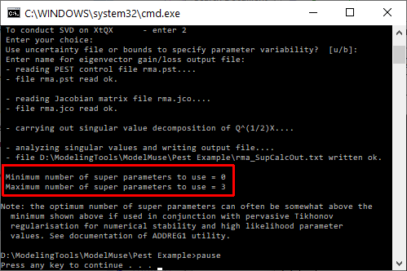

## Running PEST with Super Parameters

After choosing the number of super parameters to use, SVDAPREP can be used to create a new PEST control file incorporating the super parameters. To run SVDAPREP, select “File|Export|PEST|Modify PEST control file with SVDAPREP”. The SVDAPREP Input dialog box will appear.

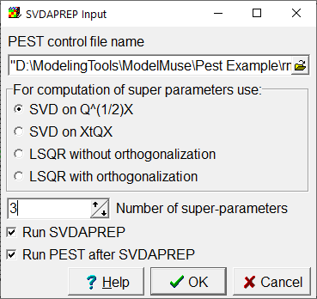

This dialog box allows the users to choose the most commonly altered inputs for SVDAPREP. To select other options, run SVDAPREP manually from the command line.

When the user clicks the OK button, ModelMuse creates a batch file for running SVDAPREP. The batch file will include a command for running PEST with the new PEST control file if the Run PEST checkbox is checked. In creating the batch file, ModelMuse performs the following actions

* It exports a new copy of the selected PEST control file.
* It creates a batch file that is used to run SVDAPREP.
* It adds a line to the batch vile to runs PSTCLEAN on the new PEST control file to remove any comments in it. The new file will have “_Svda” appended to the base name of the PEST control file.
* It adds a line to the batch file to run SVDAPREP on the PEST control file created by PSTCLEAN. The PEST control file will have the “_PostSvda” appended to the base name of the original PEST control file.
* If the Run PEST checkbox is selected, it adds a line to the batch file to run PEST using the PEST control file created by SVDAPREP.
* If the Run SVDAPREP check box is checked, it runs the batch file.

## Running the model with the optimal parameter values

As pointed out in section 10.5.2, PEST can not make a final run using the best parameter values when using SVD-assisted inversion. However, the user can do this themselves using the PARREP PEST utility program in conjunction with the best parameter values that PEST saves in a file with the extension “.bpa”.

To substitute the best parameter values, the user selects “File|Export|PEST|Replace Parameters in PEST Control File.” and selects the .bpa file for the model. The Open File dialog box will have a checkbox to run PEST after running PARREP. The base name of the .bpa file will be the base name of the original model with _svda added . ModelMuse will run PARREP with the selected file and substitute the parameters into the PEST control file. If the Run PEST checkbox was checked, it will also run PEST one time to generate the model input for the parameters recorded in the .bpa file.

# Importing and Visualizing Model Input Generated by PEST.

After running PEST, the user may wish to visualize the model inputs generated by PEST. For boundary conditions, all that is needed is to import the PVAL file generated by PEST. To do this, select “Model|Manage Parameters” and click the “Import Pval file” button. Then select the PVAL file generated by PEST. The values recorded in the PVAL file will replace the existing values in the dialog box and will be used when visualizing boundary conditions.

To visualize array data in MODFLOW models, the user selects “File|Import|Gridded Data Files.” In the Import Gridded Data Files, the user select the file or files to import. The files will be in the “arrays” subdirectory of the model directory. The file names reflect the role each file plays in the simulation. For example, if the extension is .npf.kx_1, the file is used in the NPF package for the Kx data set values in layer 1.

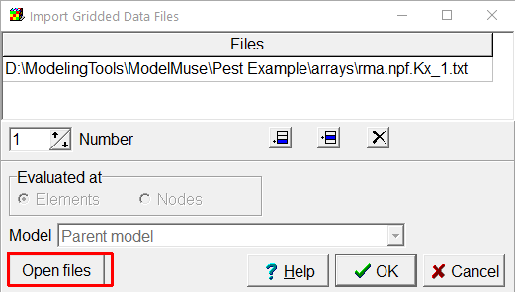

To visualize results from a SUTRA model select “File|Import|SUTRA Files” and select “File|Import|SUTRA Files.” Files with the following extensions are created by PEST and can be imported into ModelMuse to visualize them: .14B, 15B, .PVEC, and .UVEC.

# Example

The following example illustrates the application of PEST to a MODFLOW model and shows how to display the model input generated by PEST. It only has a few observations so it may not be an example of a good use of PEST. It starts with the model rma.gpt that is distributed with ModelMuse. If ModelMuse was installed with the installer, the model will be in the “Public Documents\ModelMuse\examples\MODFLOW” folder.

1. Open rma.gpt with ModelMuse. Then save it with a new name or a new location to avoid overwriting the existing copy of rma.gpt.
2. Select **Model Selection|MODFLOW 6**.
3. When prompted, agree to change the CHD boundaries in MODFLOW-2005 to CHD boundaries in MODFLOW 6.
4. Select **Model|MODFLOW Packages and Programs**.
5. In the NPF package, select the **Use horizontal anisotropy** option. (Note: the previous version of ModelMuse did not implement the K22OVERK option correctly.)  
   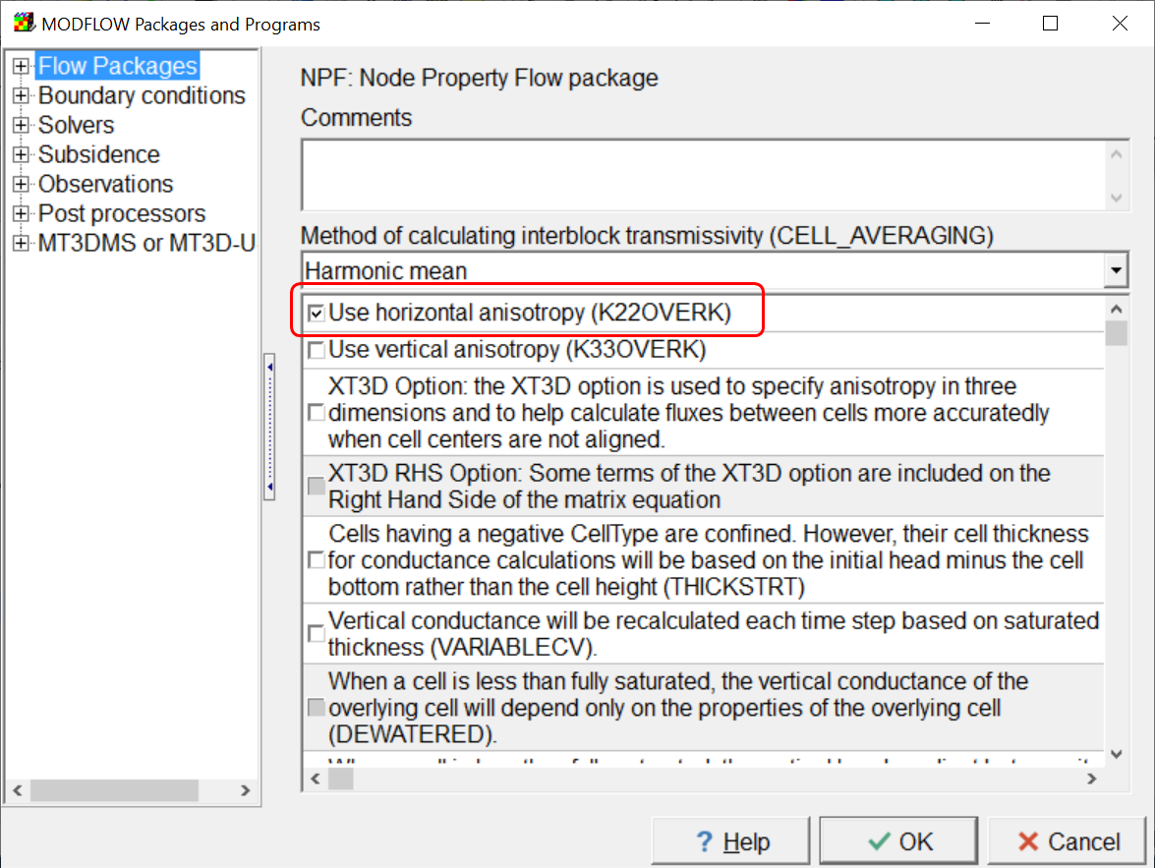
6. Activate the **Observation Utility** and deactivate MODPATH. If desired, change the **Output format** to **Binary**. Using the binary format will avoid a small amount of rounding error when processing the model results. However, the MODFLOW Observation output file would then require special software to read the results. Mf6ObsExtractor can read both text and binary versions of the Observation output file.  
   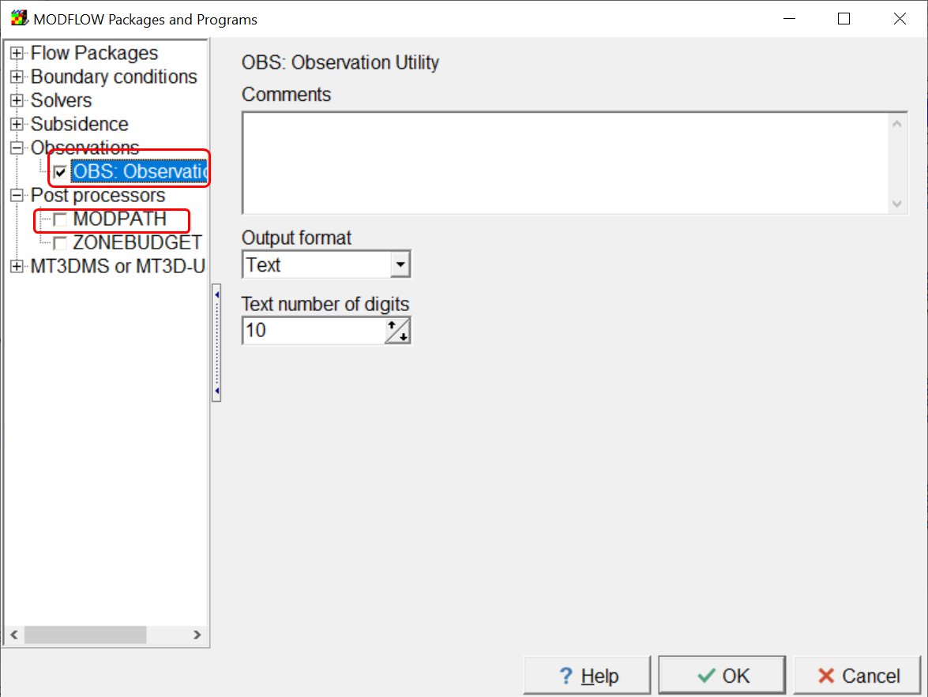
7. Select **Model|PEST Properties** and activate PEST. Then on the **Pilot Points** pane, set the **Pattern** to **Square** and the **Pilot point spacing** to 800. If desired, check the **Show candidate pilot points** checkbox.  
   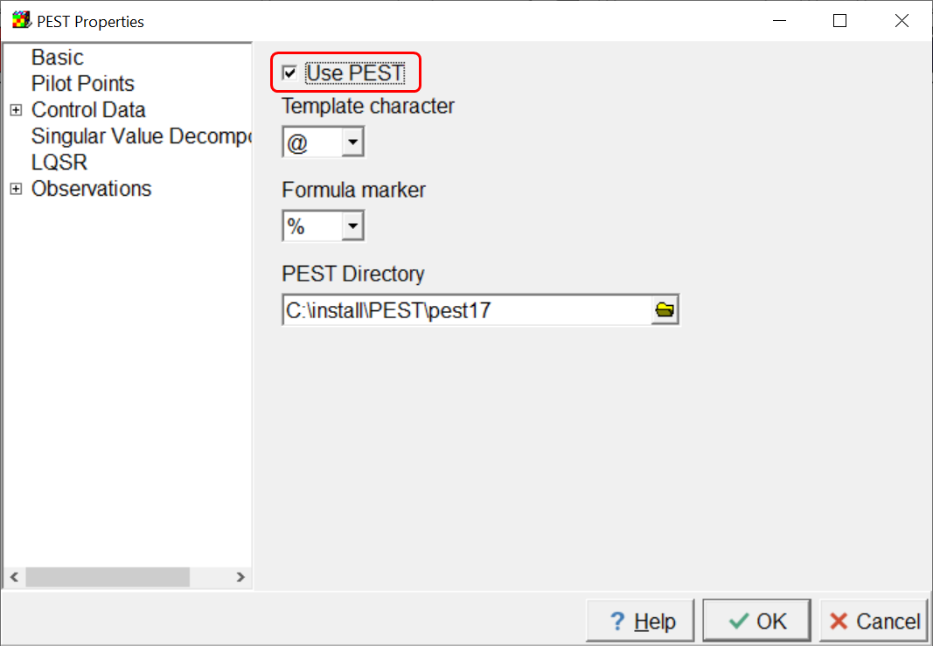 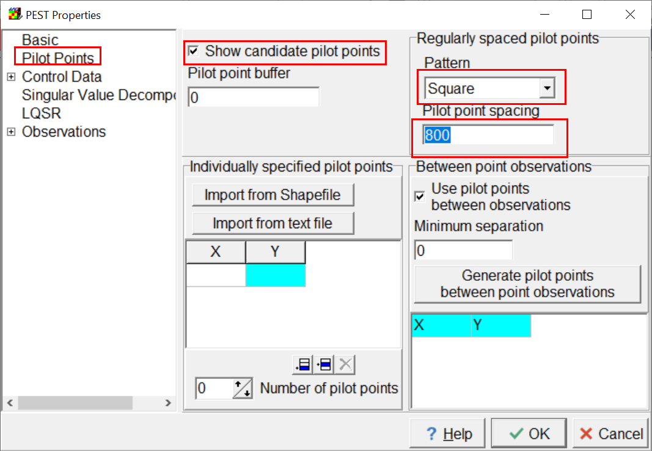
8. On the Inversion Controls 1 pane, change PHIREDLAM to 0.0001. Then click OK.  
   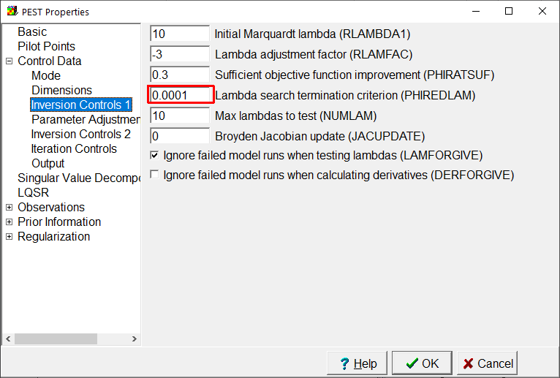
9. Next use three objects to define three observations of flow through the specified head boundary named Southern_Stream at the south end of the model. The elevations of this boundary decrease from right to left across the model. The first observation will be in columns 1-10. The second will be in columns 11-31. The third will be in columns 32-46. All the observations are similar except for their names and observation values. All should have an observation time of 631152000. The observed values of the three observations from left to right should be ‑0.1, ‑0.3, and ‑0.2.  
   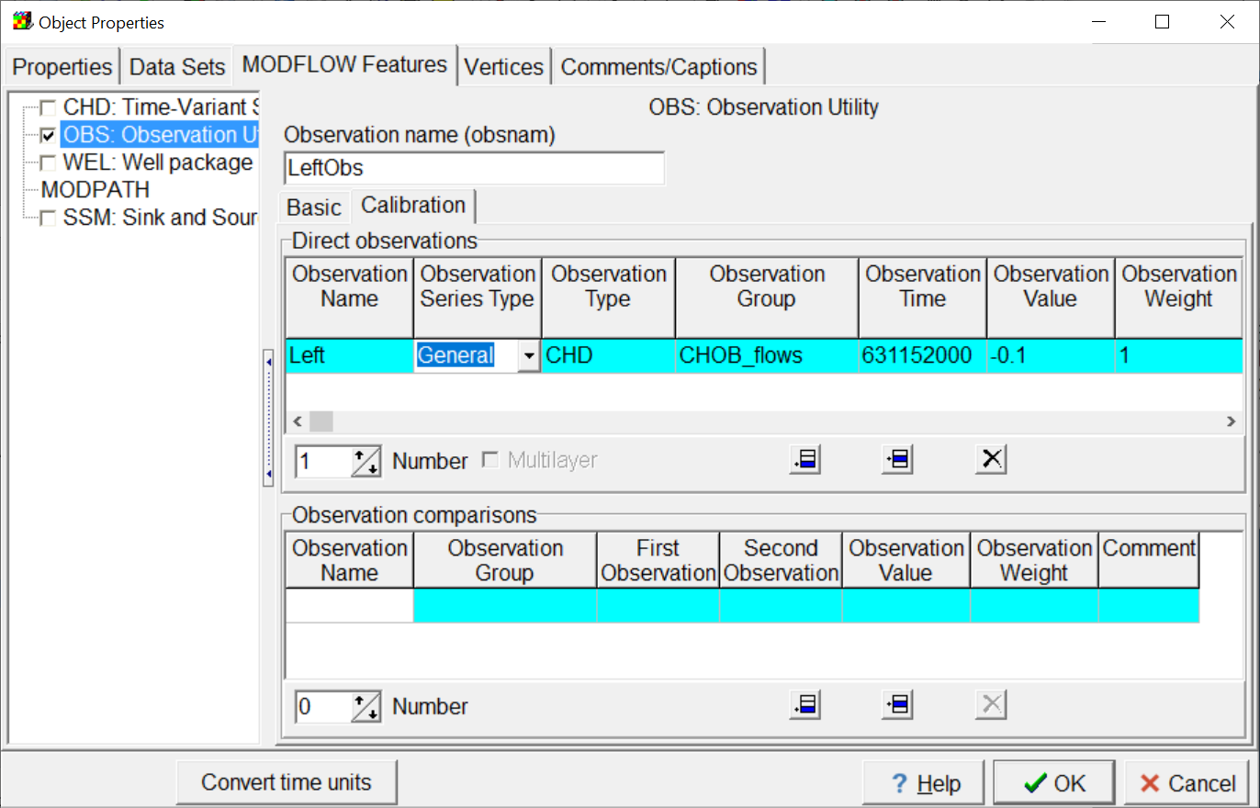
10. Select **Model|Manage Parameters** and create a new Array parameter and a new parameter and two new parameter groups. Assign the parameters and parameter groups the values shown below.  
    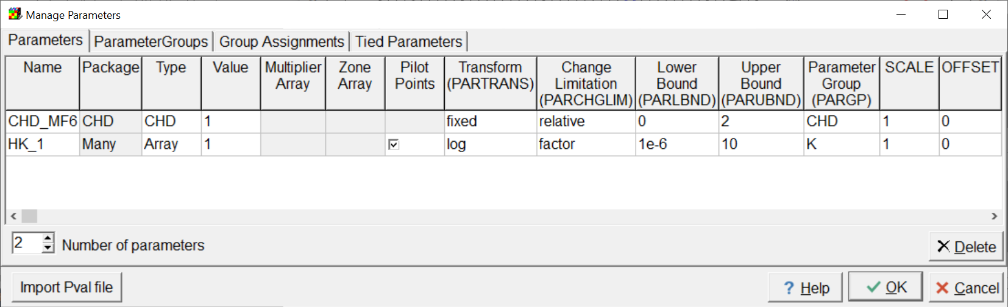  
    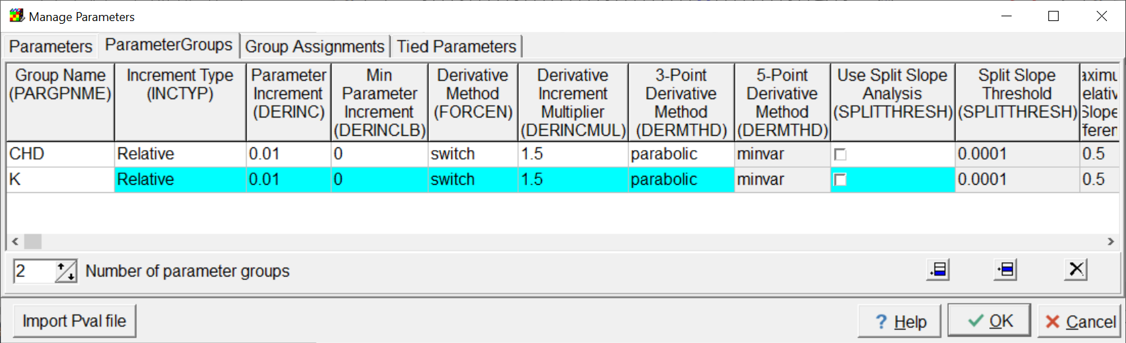
11. Select **Data|Edit Data Sets…** For the **Kx** data set, check the **PEST Parameters used** check box. Then click the **Apply** button  
    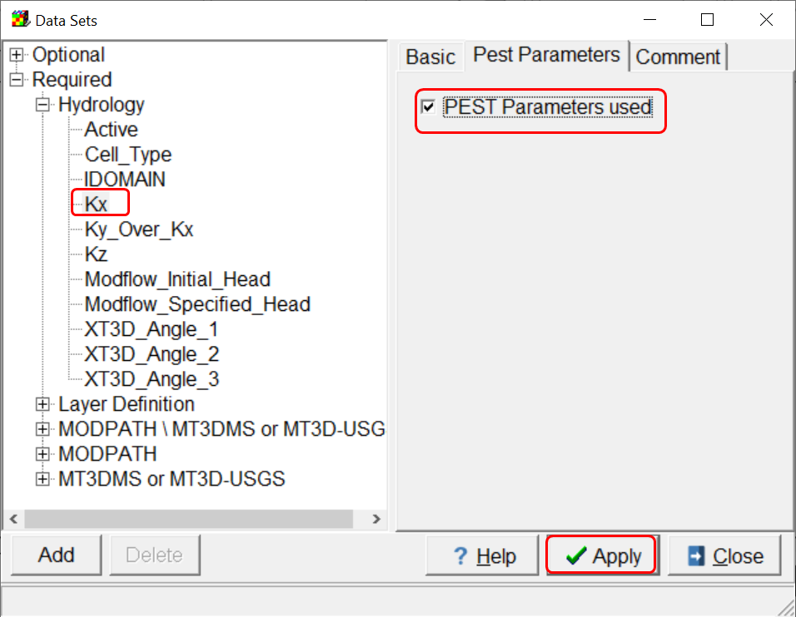
12. Set the **Default formula** for the new Kx_Parameter_Names data set to HK_1. In the Formula editor, note that HK_1 is a global variable. By setting the **Default formula** to HK_1, we are saying that HK_1 will be applied to every cell for the Kx data set or more precisely, that the pilot points associated with HK_1 will be used to assign the value of every cell during the model calibration. Click the Apply button to close the **Data Sets** dialog box.  
    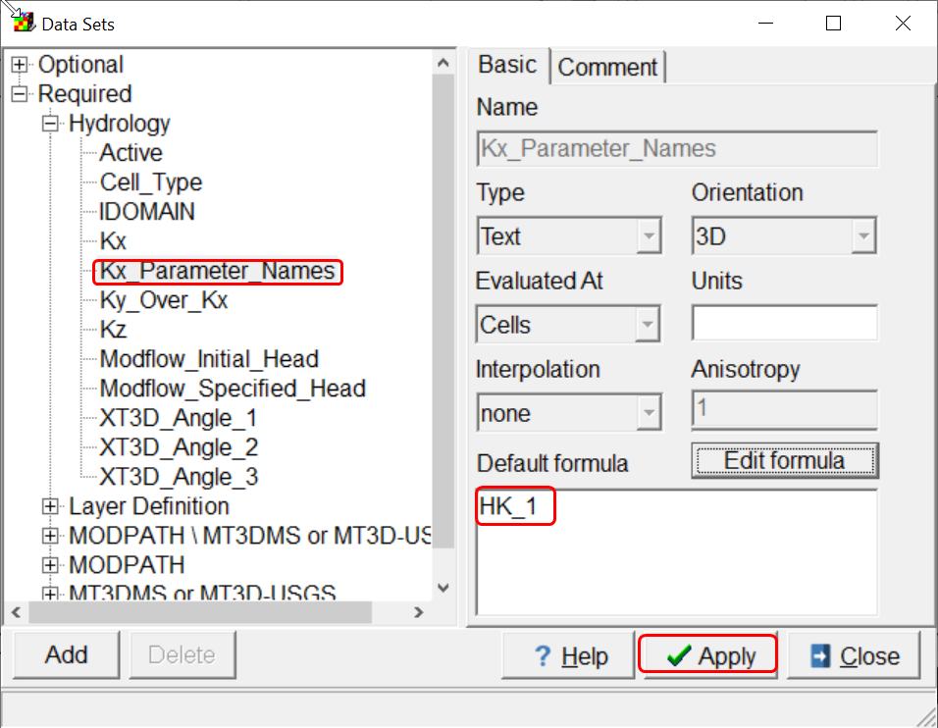 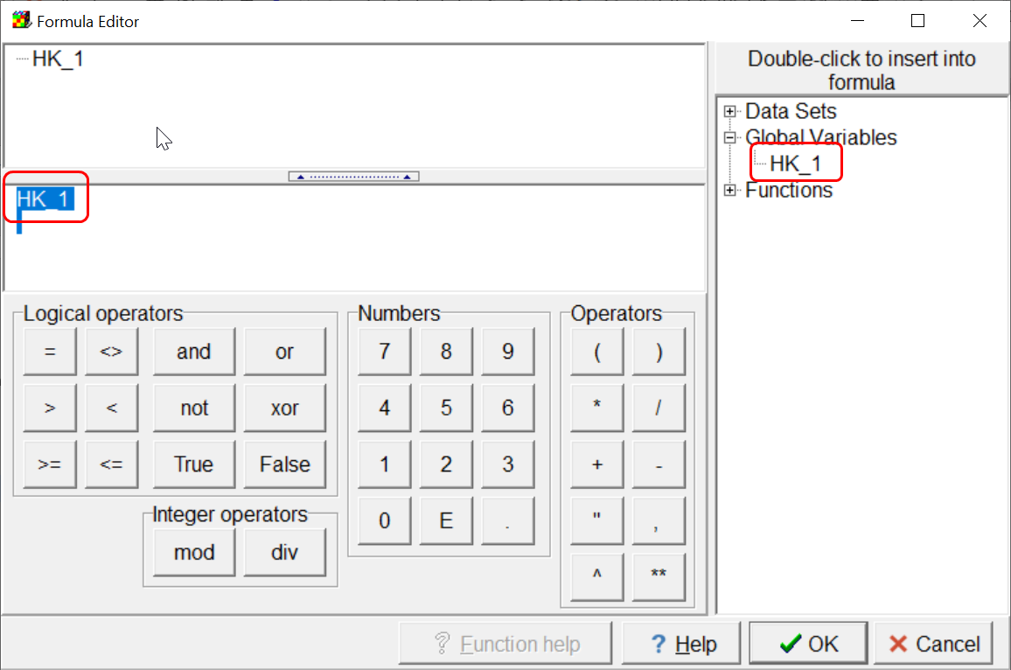
13. Select **Model|Pest Properties** and delete all the Observation groups except CHOB_flows. The easiest way to do this is by changing the **Number of observation groups**. Then click the **OK** button.  
    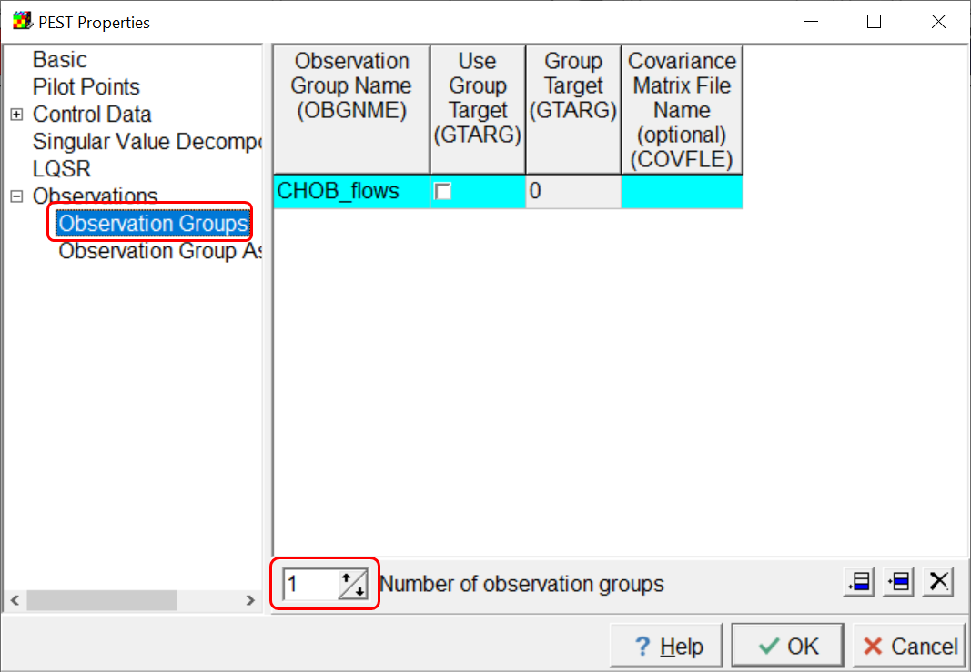
14. Save your model.
15. Select **File|Export|MODFLOW 6 input files** to run MODFLOW 6.
16. When MODFLOW is finished running and after closing ModelMonitor, examine the command line window to make sure that everything ran properly. If anything went wrong, you will need to figure out how to correct the problem.  
    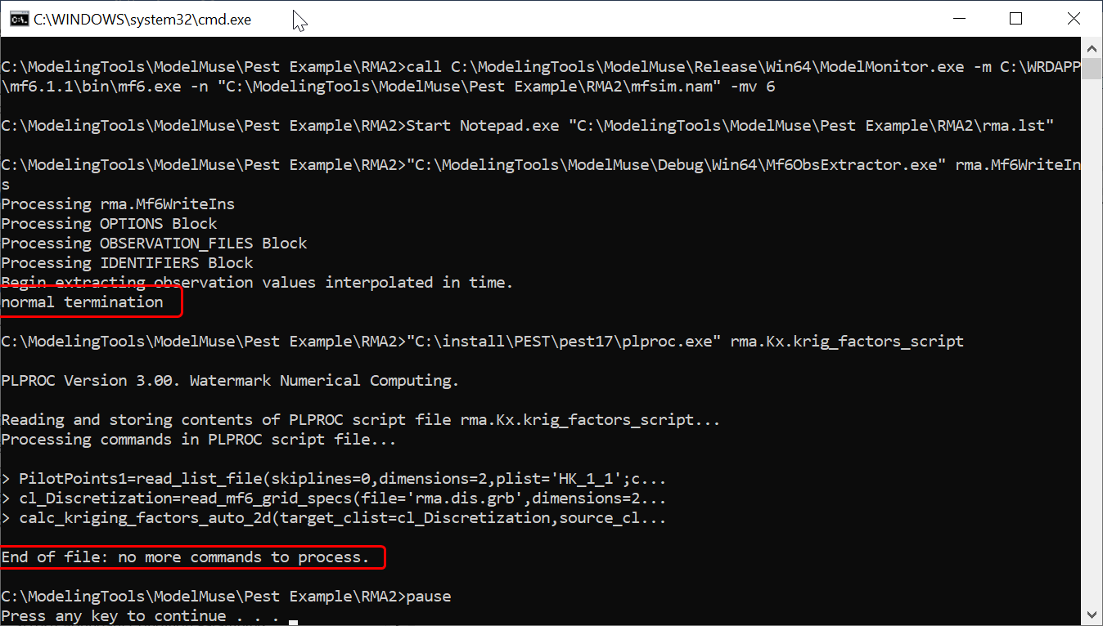
17. In the directory where you exported the model input files, there is a file named RunPestChek.bat. Double-click on it to run it. If PESTCHEK reports any errors, you will need to figure out what went wrong based on the error messages reported by PESTCHEK.  
    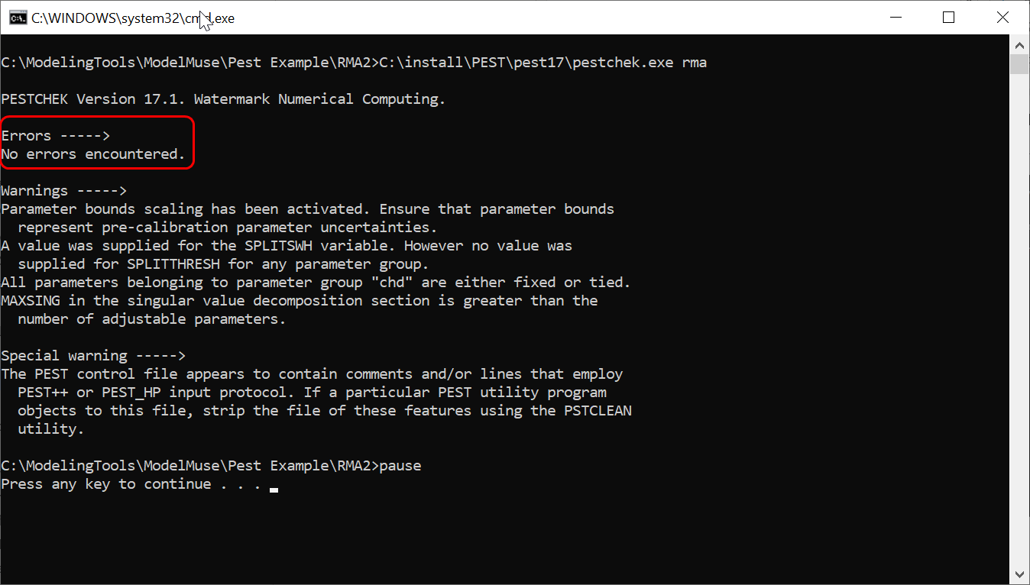
18. If PESTCHEK reports that no errors were encountered, you can start running PEST by double-clicking on another file named RunPest.bat. This will start the model calibration process and may take several hours to run.
19. When PEST has finished running, select **File|Import|Gridded Data Files**. Click the **Open files** button and select the rma.npf.Kx_1.txt file in the arrays directory within the directory where you ran the model. Click OK to import the data.  
    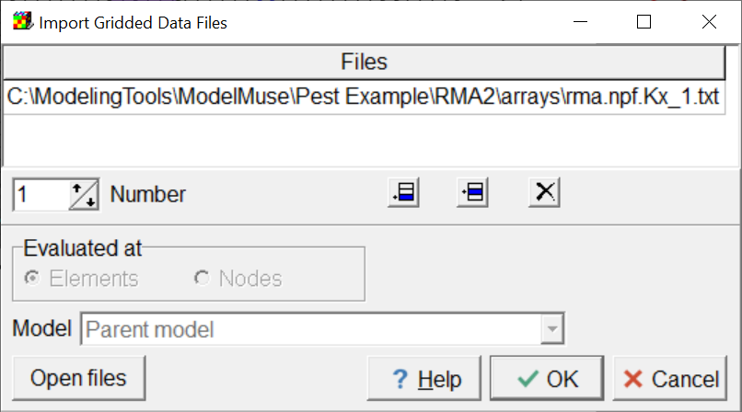
20. If you color the grid with the new data set, the results should look similar to the following.  
    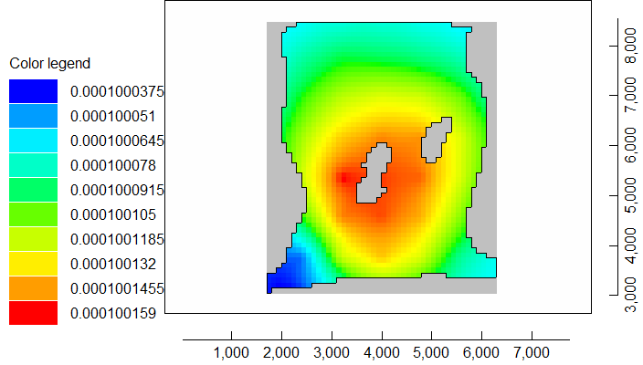
21. By default two types of prior information are included in this model: Initial Value prior information and Within Layer Continuity prior information. Between Layer prior information is not included because the model only has one layer. To see what effect they have, you can deactivate them and run PEST again. Without the prior information the hydraulic conductivities have a much different distribution as shown below.  
    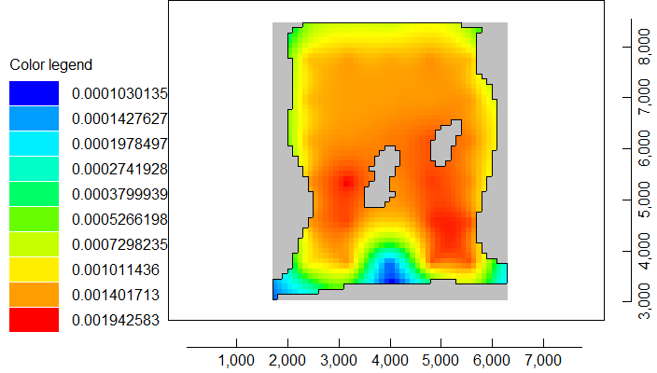
22. Reactivate the prior information and change the mode to regularization. After running PEST, the hydraulic conductivities genrated by PEST should look similar to the image below.  
    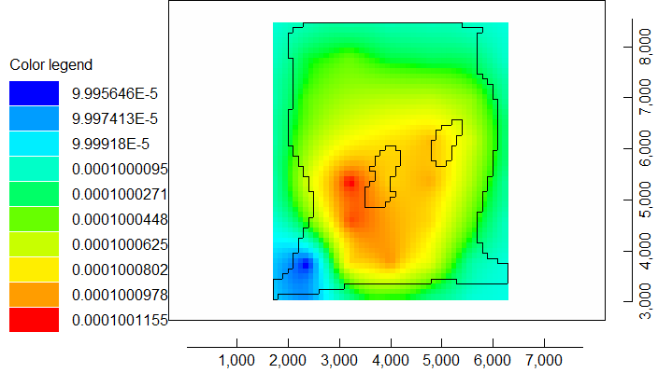
23. Next try using the SVD Assist functionality. The first thing to do is to determine the number of super parameters to use. Select “File|Export|PEST|Calculate Number of Super-Parameters”. In the SupCalc Options dialog box, set the expected value of the measurement objective function to 0.1 and click the OK button.  
    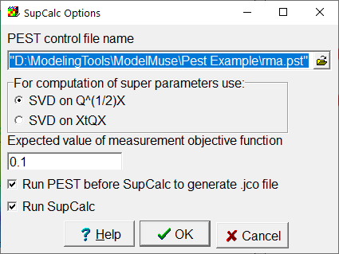
24. After first running PEST with NOPTMAX set to -2, SUPCALC will be run. The minimum and maximum number of super parameters to use will be displayed.  
    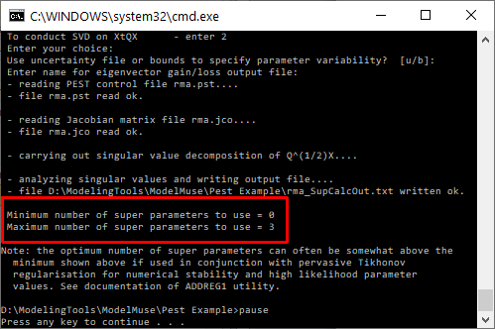
25. Next select “File|Export|PEST|Modify PEST Control File with SVDAPREP.” Enter your selected number of super-parameters and click OK.  
    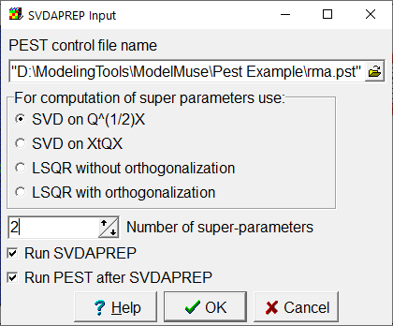
26. When the SVD Assist capability is used, PEST can not make a final run with the best parameter values. Instead, PARREP can be used to substitute the best parameter values and then run the model once. Select “File|Export|PEST|Replace Parameters in PEST Control File” and select the .bpa file. After running PARREP and and running the model, the hydraulic condutivities can be imported. The distribution of values will depend on the number of super parameters selected in the previous step.  
    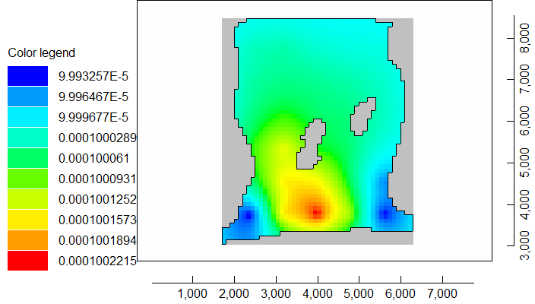

# Known Issues

There are several issues that are yet to be resolved. Here are the most prominent ones of which you should be aware.

## Linked Data Sets and Anisotropy.

In ModelMuse, there are a number of data sets whose default formulas link them with other data sets. The most prominent of these are Kx, Ky, and Kz. The default formulas for Ky is Kx and the default formula for Kz is Kx/10. Now consider the case where you want Ky to have the same value as Kx but you also want to calibrate Kx. One option would be to define one or more parameters for Kx but do nothing with Ky. PEST will then modify Kx but the value of Ky was set by ModelMuse and doesn’t instruct PEST to modify it so nothing happens to Ky so you don’t achieve your goal of having Ky be the same as Kx. Another option would be to have both Kx and Ky be estimated and to use the same parameters for both and in the same locations. This doesn’t work either so long as the formula for Ky is set to Kx. Suppose the parameter value was 1E-4 m/s. Kx then gets a value of 1E-4 times whatever value was assigned to Kx by the default formula or objects. Let’s assume that the default formula for Kx is 1 so the final value for Kx is 1E-4. The value of Ky set by the default formula is 1E-4. This is multiplied by the parameter value to get a final value of 1E-8. That is very different from your goal of having Kx equal to Ky.

The best way to handle this to meet the goal is to specify horizontal anisotropy as the model input rather than specifying Ky directly. In MODFLOW 6, this is done using an option in the NPF package. There is a similar option for vertical anisotropy. In MODFLOW-2005, horizontal anisotropy is part of the model input by default and you can also have vertical anisotropy be part of the model input. You can also have horizontal anisotropy and vertical anisotropy parameters. The parameters are specified in the “Model|MODFLOW Packages and Programs” dialog box. The vertical anisotropy option is specified in the “Model|MODFLOW Layers” dialog box.

There are no similar options for SUTRA. Your best option is probably to use tied parameters for Ky and Kz. However, this isn’t supported right now if pilot points are used.

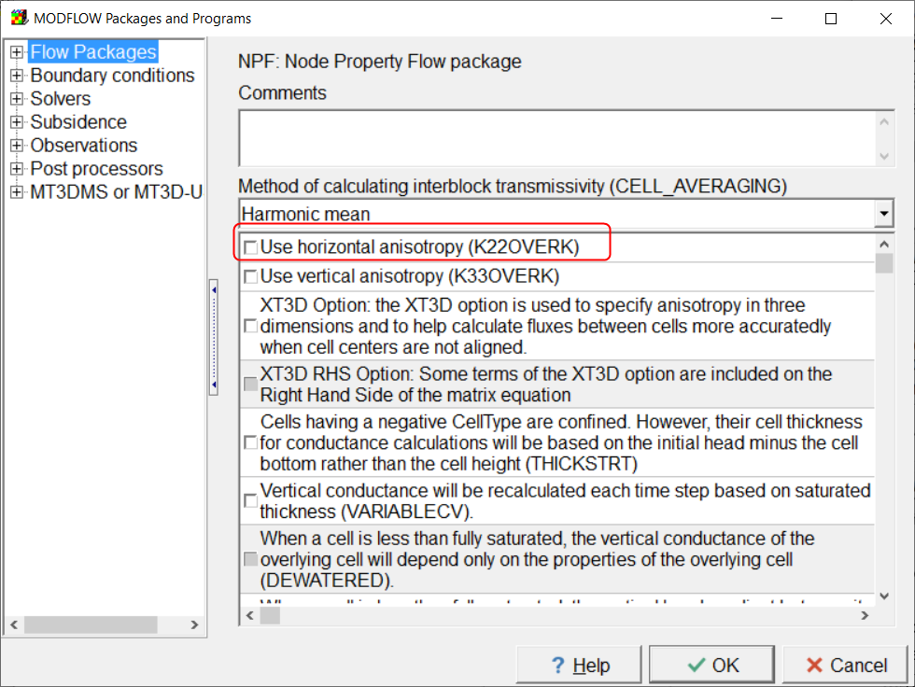

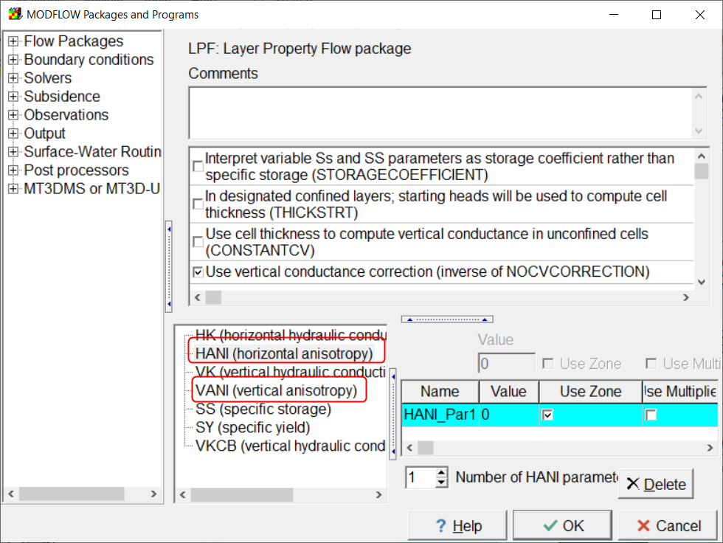 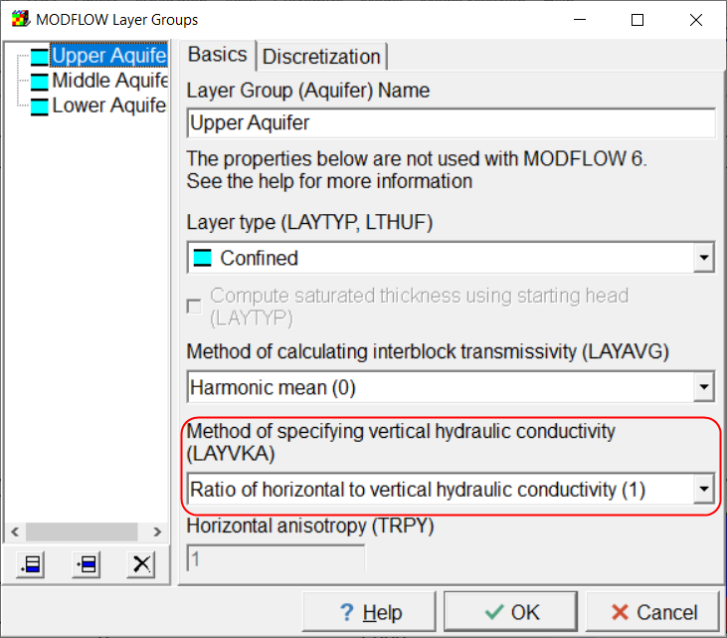

## Tied Parameters and Pilot Points.

At present, if Pilot Points is selected for a parameter in the “Model|Manage Parameters” dialog box, the parameter is replaced by a series of pilot points. Therefore you can not have such a parameter involved in tied parameters either by being tied to another parameter or by having another parameter being tied to it. However, ModelMuse doesn’t prevent you from tying such parameters in either direction. There might be some way of handling this at least in some cases but, at present, ModelMuse will just create a defective PEST control file.

## SUTRA Boundary Condition Parameters

There isn’t yet a way a specifying boundary condition parameters for SUTRA.

## Pilot Points for Boundary Conditions

ModelMuse does not yet provide a way to utilize pilot points for boundary conditions.

## Bugs in SUTRA

There are some bugs in the released version of SUTRA that inhibit it from being used with PEST. Alden Provost has provided a fixed version of SUTRA but we are still awaiting the official release of a fixed version.